**EXPENSE TRACKER**

**A PROJECT REPORT**

**for**

**Mini Project (KCA353)**

**Session (2023-24)**

**Submitted by**

**CHANDRIKI TIWARI**

**(2200290140049)**

**Submitted in partial fulfillmentof the**

**Requirements for the Degree of**

**MASTER OF COMPUTER APPLICATION**

**Under the Supervision of**

### M/S SHALIKA ARORA



**Submitted to**

**Department Of Computer Applications**

**KIET Group of Institutions, Ghaziabad**

**Uttar Pradesh-201206**

**March, 2024**

**DECLARATION**

I hereby declare that the work presented in this report entitled “Expense Tracker", was

carried out by me. I have not submitted the matter embodied in this report for the award

of any other degree or diploma of any other University or Institute.

I have given due credit to the original authors/sources for all the words, ideas, diagrams,

graphics, computer programs, experiments, results, that are not my original contribution.

I have used quotation marks to identify verbatim sentences and given credit to the

original authors/sources.

I affirm that no portion of my work is plagiarized, and the experiments and results

reported in the report are not manipulated. In the event of a complaint of plagiarism and

the manipulation of the experiments and results, I shall be fully responsible and

answerable.

Name : Chandriki Tiwari

Roll. No. : 2200290140049

Branch : MCA

(Candidate Signature)

**CERTIFICATE**

Certified that **Chandriki Tiwari <2200290140049>**has/ have carried out the project work having “**Expense Tracker**” (**Mini Project-KCA353**) for **Master of Computer Application**from Dr. A.P.J. Abdul Kalam Technical University (AKTU**)** (formerly UPTU),Lucknow under my supervision. The project report embodies original work, and studies are carried out by the student himself/herself and the contents of the project report do not form the basis for the award of any other degree to the candidate or to anybody else from this or any other University/Institution.

**Date:**

**Chandriki Tiwari (2200290140049)**

This is to certify that the above statement made by the candidate is correct tothe best of my knowledge.

Date:

**Ms. SHALIKA ARORA Dr. Arun Tripathi**

**Asst. Professor Head**

**Department of Computer Applications Department of ComputerApplications**

**KIET Group of Institutions, GhaziabadKIET Group of Institutions, Ghaziabad**

**Expense Tracker**

**Chandriki Tiwari**

**ABSTRACT**

This project is based on an expense and income tracking system. This project aims to create an easy, faster and smooth tracking system between the expense and the income. This project also offers some opportunities that will help the user to sustain all financial activities like digital automated diary.

As the name itself suggests, this project is an attempt to manage our daily expenses in a more efficient and manageable way. Sometime we can’t remember where our money goes. And we can’t handle our cash flow.

For this problem, we need a solution that everyone can manage their expenses. So we decided to find an easier way to get rid of this problem. So, our application attempts to free the user with as much as possible the burden of manual calculation and to keep the track of the expenditure.

Instead of keeping a diary or a log of the expenses, this application enables the user to not just keep the control on the expenses but also to generate and save reports.

With the help of this application, the user can manage their expenses on a daily, weekly and monthly basis. Users can insert and delete transactions as well as can generate and save their reports.

**ACKNOWLEDGEMENTS**

Success in life is never attained single-handedly. My deepest gratitude goes to my project supervisor, **Ms. SHALIKA ARORA** for his/ her guidance, help, and encouragement throughout my project work. Their enlightening ideas, comments, and suggestions.

Words are not enough to express my gratitude to Dr. Arun Kumar Tripathi,Professor and Head, Department of Computer Applications, for his insightful comments and administrative help on various occasions.

Fortunately, I have many understanding friends, who have helped me a lot on many critical conditions.

Finally, my sincere thanks go to my family members and all those who have directly and indirectly provided me with moral support and other kind of help. Without their support, completion of this work wouldnot have been possible in time. They keep my life filled with enjoyment and happiness.

**Chandriki Tiwari**

### TABLE OF CONTENTS

TITLE PAGE.................................................................................

CERTIFICATE............................................................................

ACKNOWLEDGEMENT.............................................................

ABSTRACT...................................................................................

LIST OF FIGURES........................................................................

CHAPTER 1: INTRODUCTION.

1.1

### CHAPTER5:IMPLEMENTATION 12-25

* + 1. Home Screen 12
    2. From Camera Option
    3. From Gallery Option
    4. VariousOptionswhileadjustingimage
    5. Save Option
    6. ReviewOption
    7. Settings
  1. DFD
     1. Level 0 DFD
     2. Level 1 DFD

### CHAPTER6:PROJECTRELEVANCE 26-28

* 1. Contribution to society
  2. Ethicsand Conclusion

### CHAPTER7:CONCLUSIONANDFUTUREPROJECTIONS 29

* 1. Conclusion

**REFERENCE** 30

### CONTRIBUTIONOFEVERYMEMBER 31

**ANNEXURE** 32-40

**LISTOFFIGURES**

|  |  |  |
| --- | --- | --- |
| **S.No** | **Name** | **Page No.** |
| 5.1 | HomeScreen |  |
| 5.2 | FromCameraOption |  |
| 5.3 | FromGalleryOption |  |
| 5.4 | GreyScale |  |
| 5.5 | Invert |  |
| 5.6 | Flips |  |
| 5.7 | Overview |  |
| 5.8 | SavingImage |  |
| 5.9 | GalleryOverview |  |
| 5.10 | ReviewOption |  |
| 5.11 | Settings |  |
| 5.12 | DFDlevel0 |  |
| 5.13 | DFDlevel1 |  |

**CHAPTER 1**

**INTRODUCTION**

**1.1 Introduction**

Expense Tracker System is designed to keep a track of Income-Expense of user on a day-to-day basis. This System divides the Income based on daily expenses. If exceed day’s expense, system will calculate income and will provide new daily expense allowed amount. It will helps to manage over all expense and income. Businesses also utilize expense management software to process, pay, and audit employee-initiated expenses. Expense management software simplifies and automates a business’ expense entry, eliminates paper trail, and reduces administrative effort. Expense management software analyzes overall expenses, identifies cost-saving opportunities, and controls excessive spending. “Expense Tracker” is developed to manage the daily expenses in a more efficient and manageable way. By using this application we can reduce the manual calculations of the daily expenses and keep track of the expenditure. In this application, user can provide his income to calculate his total expenses per day. Budgeting systematically and Expense Tracking takes a crucial role in managing the expenses of business organizations. Expense tracking will bring in several advantages for an organization. That are helpful for the stake-holders in processes of expense. The expense tracker will help any organization to deal with all their expenses more efficiently. By using software for managing expense tracking will help to control unnecessary expenses. There are several benefits and advantages of using online expense trackers, expense tracking makes any organization run faster and smoother.

**1.2 Motivation**

The motivation to work in this project is actually our real-life experience. As a user We face many difficulties in our daily file. In our daily life money is the most important portion and without we cannot last one day in the earth but if we keep on track all financial data then we can be overcome this problem. Most of the people cannot track their expense and income one way the face in money crisis and depression. This situation motivates us to make an android app to tracking all financial activities. Using the Daily Expense Tracker user can be tracking expense day to day and making life tension free.

**1.3 Objective**

The primary purpose of the Expense Tracker is to offer a user-friendly and efficient platform for individuals and businesses to manage their expenses. By leveraging technology, the project aims to simplify the process of recording, categorizing, and analyzing expenditures.

Our goal is to create an expense tracking system where user can be tracking all financial activities and view previous income and expense report.

* User can easily review the reports daily, weekly, monthly or yearly.
* User can update or delete records.
* Create Category and Change currency.
* Add Expense and Income.

**1.4 Scope and Limitations**

* The Expense Tracker will cover the fundamental aspects of expense management, including expense entry, categorization, and reporting.
* The system will be accessible through a web-based interface, ensuring compatibility across various devices.
* While the system aims to provide real-time tracking, it may not account for potential delays in financial data updates from external sources.
* The project may not include advanced features such as predictive budgeting or integration with specific financial institutions due to time and resource constraints.

**CHAPTER 2**

**BACKGROUND**

**2.1 Introduction**

Daily Expense is a simple web application for Android devices. Writing in a user's pocket handbook is as convenient and easy as it is.Users just need to enter revenue and expense as their revenue and speed, and the app calculates it for users. This application is very easy, fast and secure with money calculation .

**2.2 Literature Survey**

(Babad and Balachandran, 1993) states that traditional cost accounting systems maintain all overheads in one pool and give equal weight to all activities and costs in it We always have known that “pen is mightier than sword” but that thing doesn’t fit with every specific tasks it varies from need-to-need or tasks-to-tasks these days when the amount data is quite enormous it becomes way more difficult to handle them off. Soon excel also become a way on maintain a record of expenses and analysis. Though excel was an effective way, but it becomes way more difficult to handle expenses. Soon excel also become a way on maintain a record of expenses and analysis. Though excel was an effective mode to store data but that project had a drawback in its existing model as it can’t handle the data efficiently in addition to that it wasn’t user-friendly and an unpopulated data project.

A research at university on Tennessee on expense tracker of by (Dan Underwood, 2011): In which using excel accounting team designed a Cost Allocation tool 1 in which a spreadsheet is used to allocate the product category both by site and the cooperation and a Cost allocation tool 2 which is a developed to further integrate and allocate cost to identify which manufacturer is profitable or which is not. This research used excel and designed this CAT tool in which both the spreadsheets are required to use to identify where we could reduce expenses or better managed it. (Girish Bekaroo, 2007) did a research on intelligent online budget that manages the expenses and used to give the graphical analysis of data. It uses a Rational Unified Method (RUP) which was way more efficient and advantageous in the way it used to promote code reuse and encapsulation in which CSS and xml technologies has been used.

Students of Sikkim Manipal University an income expense for housewives which not just counts the amount but also maintains date and calendar record of the person as well they used the clustering technique to maintain their data storage. (Stephan snow and Dhayal Vyas, 2015) mentioned in his paper. “Managing finances is a practice carried out daily in homes across the world. Despite this, the practice is not yet a strong focus for HCI work in the home”.

Researchers of Nandha and Anna university (2016) created an android version of expense manager in with they used post and remark techniques for underlining the expenses and some of the data mining features for analyzing the market value well. (R N Rajprabha, 2017) created an android version of family budget manager with later evolved in PDA and tablet features. (Ravi Sharma, 2017) stated users sometimes feels uncomfortable in sharing their personal information with an app and he suggested security and usability are two major concerns. Even the advanced UI needs to maintain retention. Researchers of Mother Terresa university, Andhra Pradesh (2019) also stated an online income and budget tracker in a website mode but that project used.

**2.3 Related Works**

We looked through the Google play store and found some apps that are similar to our application but there are some features missing which this type of application need to have. So we combined all the features in our app and added some new features and make it useful with better UI.

Some related works are mentioned below with a short detail:

* Monefy Money Manager [1]: How to track your expenses successfully? We know that¬ it‟s easy. You only need to add each expense you do… no more than that! And Monefy is going to help you. Just add new records when you are buying a coffee or taking a taxi. It‟s done in one click, because you don‟t need to fill anything except the amount. It has never been so quick and enjoyable!
* Expenses Tracker [2]: Expense Tracker - Money Manager¬& Budget can quickly and easily track your income and expenses, which will help you avoid making accidental expenses.
* Expense Manager [3]: Expense Manager is simple, intuitive, stable and feature-rich¬ app that is just designed for you. Everything you need at your fingertips to manage the expenditures, checkbook and budgets.

**2.4Identification of problem and issues**

**A) How it Actually Works In existing**, we need to maintain the Excel sheets, CSV etc. files for the user daily and monthly expenses. In existing, there is no as such complete solution to keep a track of its daily expenditure easily. To do so a personas to keep a log in a diary or in a computer, also all the calculations needs to be done by the user which may sometimes results in errors leading to losses.

**B) Drawbacks of the Existing System** There can be many disadvantages of using a manual accounting system. Accounting, for any business, can be a complex undertaking. A manual accounting system requires you to understand the accounting process in a way that may be unnecessary with a computerized accounting system. This can be an advantage or a disadvantage, depending on the person doing the bookkeeping; often, a specially trained professional is needed to ensure that accounting is done properly. Unraveling the complexity of your financial records by hand may be time consuming. Since it takes time to generate reports.

**CHAPTER 3**

**PROBLEMFORMULATION**

**3.1 Problem Statement**

Basically, we can see that today everyone seek towards his savings. Person wants that in this era of inflation how he/she can control his/her expenses and save money for future use. Obviously, they are seeking towards such an application which guides them how they can meet their expenses in efficient manner and also save their money for future use.

Individuals and businesses often struggle with manual and inefficient methods of tracking and managing expenses. Traditional spreadsheets or generic tools lack the tailored features required for a comprehensive expense management system. Users face difficulties in categorizing and analyzing expenses, leading to a lack of control over their financial activities.

**3.2Formulation of the problem**

Expense management is a common challenge faced by individuals and businesses alike. Traditional methods of tracking expenditures, often relying on manual entry or generic tools, prove to be inefficient and lack the specificity required for effective financial control. The absence of a dedicated and user-friendly expense tracking system results in several key issues:

Inaccuracies in Expense Recording: Manual entry of expenses is prone to errors, leading to inaccuracies in financial records. Lack of a systematic approach hinders users from categorizing and recording expenses consistently.

Delayed Insights and Decision-Making: The absence of real-time tracking means users do not have immediate access to their current financial standing.Delayed insights into spending patterns hinder informed decision-making, preventing timely adjustments to budgets.

Time-Consuming Processes: Existing methods require significant time and effort to manage and organize financial transactions. Hectic processes contribute to user frustration and may result in neglect or incomplete recording of expenses.

Limited Analysis and Planning: Generic tools do not offer comprehensive reporting capabilities, limiting users' ability to analyze their spending over time. Users lack the tools needed to plan and adjust budgets based on historical expenditure patterns.

**3.3 Solution Approach**

The Expense Tracker project adopts a multifaceted solution approach to address the identified challenges in expense management. The key components of the solution encompass user interface design, real-time tracking, comprehensive reporting, security measures, scalability, cross-platform accessibility.

**User-Friendly Interface:**

Objective: Develop an intuitive and accessible interface for seamless user interaction.

Implementation: Implement a user-friendly design that simplifies expense entry, categorization, and navigation. Provide clear instructions and visual cues to guide users through the process.

**Scalability:**

Objective:Design the system to accommodate growing user needs and potential future enhancements.

Implementation: Develop the Expense Tracker with scalability in mind, allowing for the addition of features, users, and data without compromising performance.

**Cross-Platform Accessibility:**

Objective: Enhance user convenience by providing accessibility across various platforms.Implementation: Develop a responsive web-based interface that adapts to different devices and screen sizes, ensuring users can manage their expenses seamlessly on both desktop and mobile platforms.

**Real-Time Tracking:**

Objective: Enable users to monitor their expenses in real-time for immediate insights.

Implementation: Implement a real-time tracking system that updates financial information as transactions occur. Users can access up-to-date data, facilitating informed decision-making.

**CHAPTER 4**

**MODULES**

**4.1 Administrative Modules**

In the development of the Expense Tracker web application, several administrative modules have been incorporated to facilitate efficient management and oversight. These administrative modules serve to streamline various aspects of the system, allowing for better control and supervision. The key administrative modules include:

**1. User Authentication and Authorization:**

This module handles user accounts and access control within the application. Users can register for a new account, providing necessary details like username, email, and password. Upon registration, users can log in securely to access their personalized dashboard.

**2.Add Expense :**

The "Add Expense" module allows users to record and track their expenses within the expense tracker web application.The module presents users with a form where they can input details about the expense, including the title, description, amount, and date.

**3.Add Income:**

The "Add Income" module enables users to log and manage their amount of income within the expense tracker web application.

**4.Modify Expense:**

The User can delete that added expensedata from expense list also the added data in expense list can be edit or modified.

**5.Budget Management:**

This module empowers users to manage their budget effectively. Users can set up their initial budget based on their financial goals and preferences. They have the flexibility to adjust budget limits as needed and monitor their progress towards achieving their budgeting objectives. The module provides clear indicators of budget status to keep users informed about their financial situation.

**6.Expense management:**

This module empowers users to manage their budget effectively. Users can set up their initial budget based on their financial goals and preferences. They have the flexibility to adjust budget limits as needed and monitor their progress towards achieving their budgeting objectives. The module provides clear indicators of budget status to keep users informed about their financial situation.

**CHAPTER 5**

**REQUIREMENT SPECIFICATION**

**4.1 Process Flow Diagram**

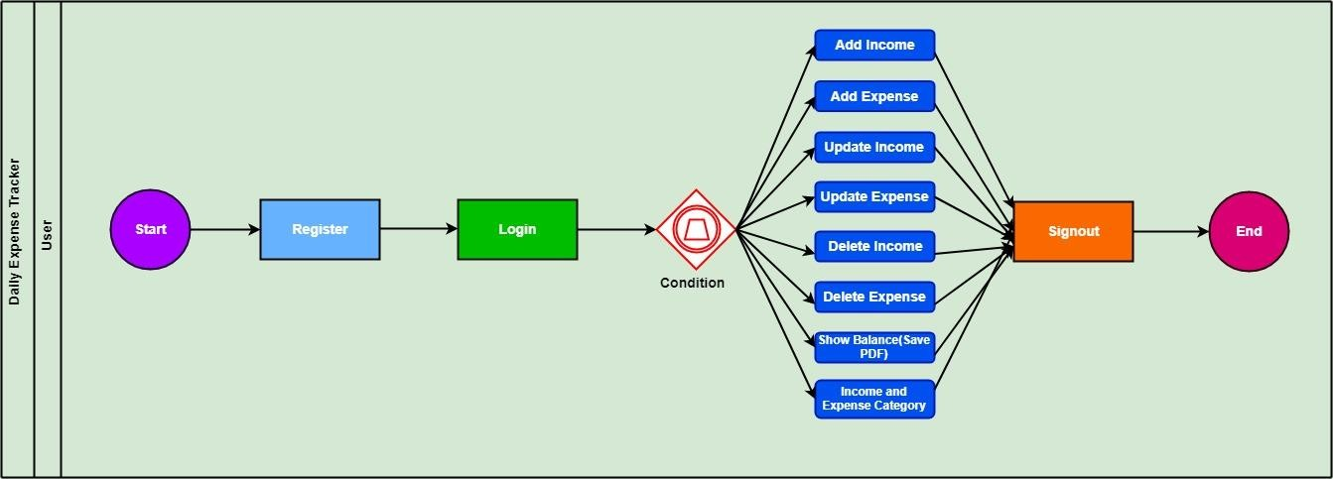The process model is shown below:

Fig. 4.1:

**4.2 Hardware Requirements**

Server:

A server to host the web application. This could be a cloud-based server (e.g., AWS, Azure, Google Cloud) or a traditional web hosting service.

Storage:

Sufficient storage space for storing user data, expenses, and any associated documents or receipts.

Network:

A stable internet connection to ensure the web application is accessible to users.

**4.2 Software Requirements**

Web Browser:

The Expense Tracker is a web-based application, so users will need a modern web browser (e.g., Google Chrome, Mozilla Firefox, Safari) to access the system.

Version Control

Consider using version control systems (e.g., Git) for collaborative development and code management.

Code Editor

A code editor for writing and managing HTML, CSS, and JavaScript code. For this project Visual Studio vode editor is used.

Web Server:

A web server (e.g., Apache, Nginx) to serve the HTML, CSS, and JavaScript files to users.

**CHAPTER 6**

**DIAGRAMS**

**6.1 Entity Relationship Diagram**

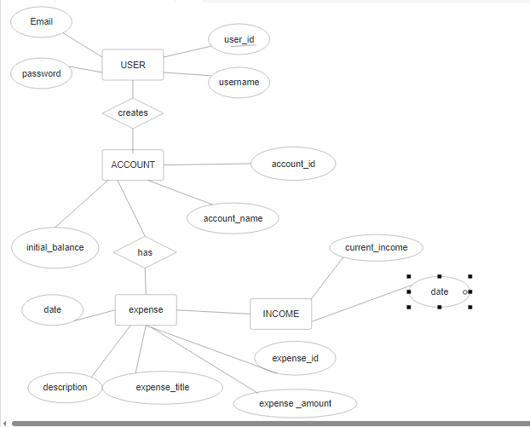

**Fig 6.1: ER Diagram**

**6.2 Data Flow Diagram:**

**Fig 6.2:Context Diagram (0-level DFD):-**

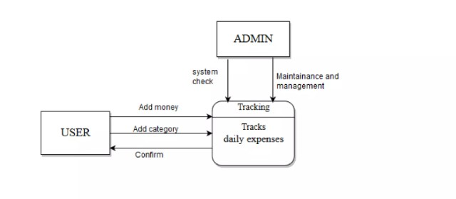**Fig 6.3: DFD level 1:**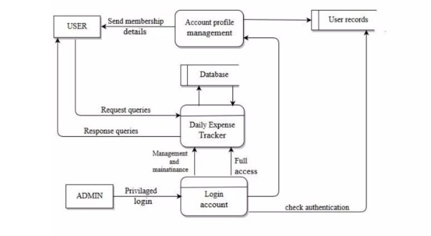

**6.4 Use Case Modelling and Description**

TheUseCaseisshownbythefigbelow.

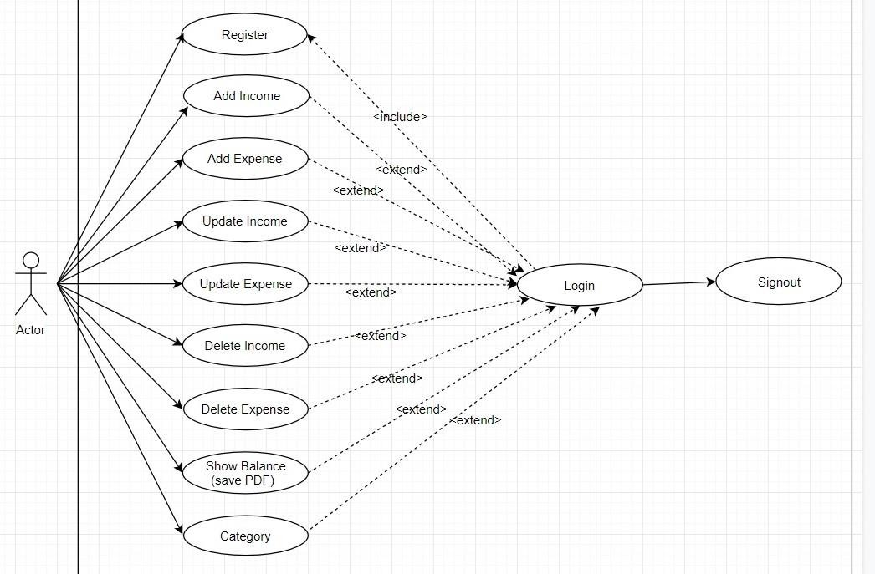

**Fig. 6.4: Use Case Diagram**

Table3.1:DescriptionofUseCaseforRegistration

|  |  |
| --- | --- |
| **Name:** | Registration |
| **Precondition:** | None |
| **Actor** | User |
| **PrimaryPath:** | 1)TypeName2)TypeEmail3)TypePass   1. TypeConfirmPass 2. PressRegistration„Button‟ |
| **ExceptionalPath:** | 1.1)Nameisrequired  2.1)Emailisrequired   * 1. Passisrequired   2. Passwordmustbelargerthan6characters |

|  |  |
| --- | --- |
| **Name:** | Login |
| **Precondition:** | Registration |
| **Actor** | User |
| **PrimaryPath:** | 1. TypeEmail 2. TypePass 3. ClickLogin„Button‟ |

Table3.2 DescriptionofUseCaseforLogin

|  |  |
| --- | --- |
| **ExceptionalPath:** | 2.1)Email isrequired   * 1. Passisrequired |

Table3.3:DescriptionofUseCaseforAddIncome

|  |  |
| --- | --- |
| **Name:** | AddIncome |
| **Precondition:** | Login |
| **Actor:** | User |
| **PrimaryPath:** | 1) user canaddincome |
| **ExceptionalPath:** | 1)AddIncomeisrequire |

Table3.4:DescriptionofUseCaseforAddExpenses

|  |  |
| --- | --- |
| **Name:** | AddExpenses |
| **Precondition:** | Login |
| **Actor:** | User |
| **PrimaryPath:** | 1) user canaddexpenses |
| **ExceptionalPath:** | 1)AddExpensesisrequire |

Table3.5:DescriptionofUseCaseforDeleteIncome

|  |  |
| --- | --- |
| **Name:** | DeleteIncome |
| **Precondition:** | Login |
| **Actor:** | User |
| **PrimaryPath:** | 1)user candeleteincome |
| **ExceptionalPath:** | 1)DeleteIncomeisrequire |

Table3.6:DescriptionofUseCaseforDeleteExpenses

|  |  |
| --- | --- |
| **Name:** | DeleteExpenses |
| **Precondition:** | Login |
| **Actor:** | User |
| **PrimaryPath:** | 1)user candeleteexpenses |
| **ExceptionalPath:** | 1)DeleteExpensesisrequire |

Table3.7:DescriptionofUseCaseforUpdateIncome

|  |  |
| --- | --- |
| **Name:** | UpdateIncome |
| **Precondition:** | Login |
| **Actor:** | User |
| **PrimaryPath:** | 1) user canupdateincome |
| **ExceptionalPath:** | 1)UpdateIncomeisrequire |

Table3.8:DescriptionofUseCaseforUpdateExpenses

|  |  |
| --- | --- |
| **Name:** | UpdateExpenses |
| **Precondition:** | Login |
| **Actor:** | User |
| **PrimaryPath:** | 1) user canupdateexpenses |
| **ExceptionalPath:** | 1)UpdateExpenses isrequire |

Table3.9:DescriptionofUseCaseforShowBalance

|  |  |
| --- | --- |
| **Name:** | ShowBalance |
| **Precondition:** | Login |
| **Actor:** | User |
| **PrimaryPath:** | 1)usercanshowbalance |
| **ExceptionalPath:** | 1)ShowBalance isrequire |

Table3.1.1: DescriptionofUseCaseforCategory

|  |  |
| --- | --- |
| **Name:** | Category |
| **Precondition:** | Login |
| **Actor:** | User |
| **PrimaryPath:** | 1) usercanadd incomeand expensecategory |
| **ExceptionalPath:** | 1) Categoryisrequire |

**6.5 Logical Data Model**

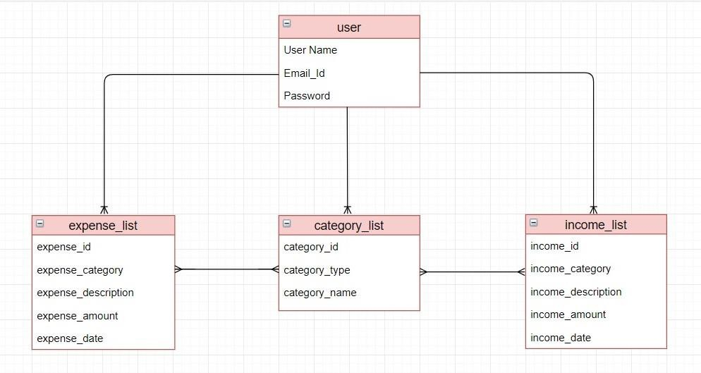The Logical Data Model is shown by the figure below:

**CHAPTER 7**

**Design Specification**

**Front-end Design**

The front in design plays an important role for any application. This has a lot to do withmaking the user-friendly with the interface. We used in front-end design in HTML, CSS, JavaScript. Below isthe interfaceforourusers.

The fig4.1andfig4.2isgivenbelowisRegisterandlogininterface.

**Fig 5.1 : User Login Interface Fig 5.2 : User Registration**

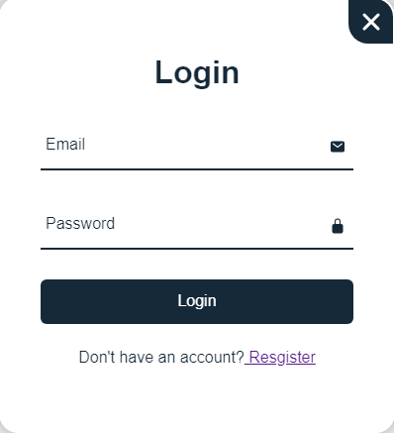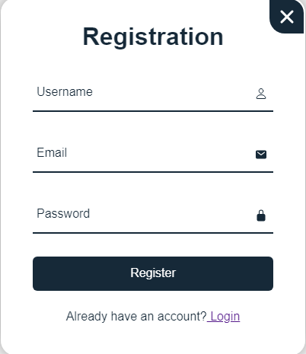

The fig 5.3 is given below is dashboard and dashboard option button for Userinterface.Usercaneasilyview the balanceaccording to date.

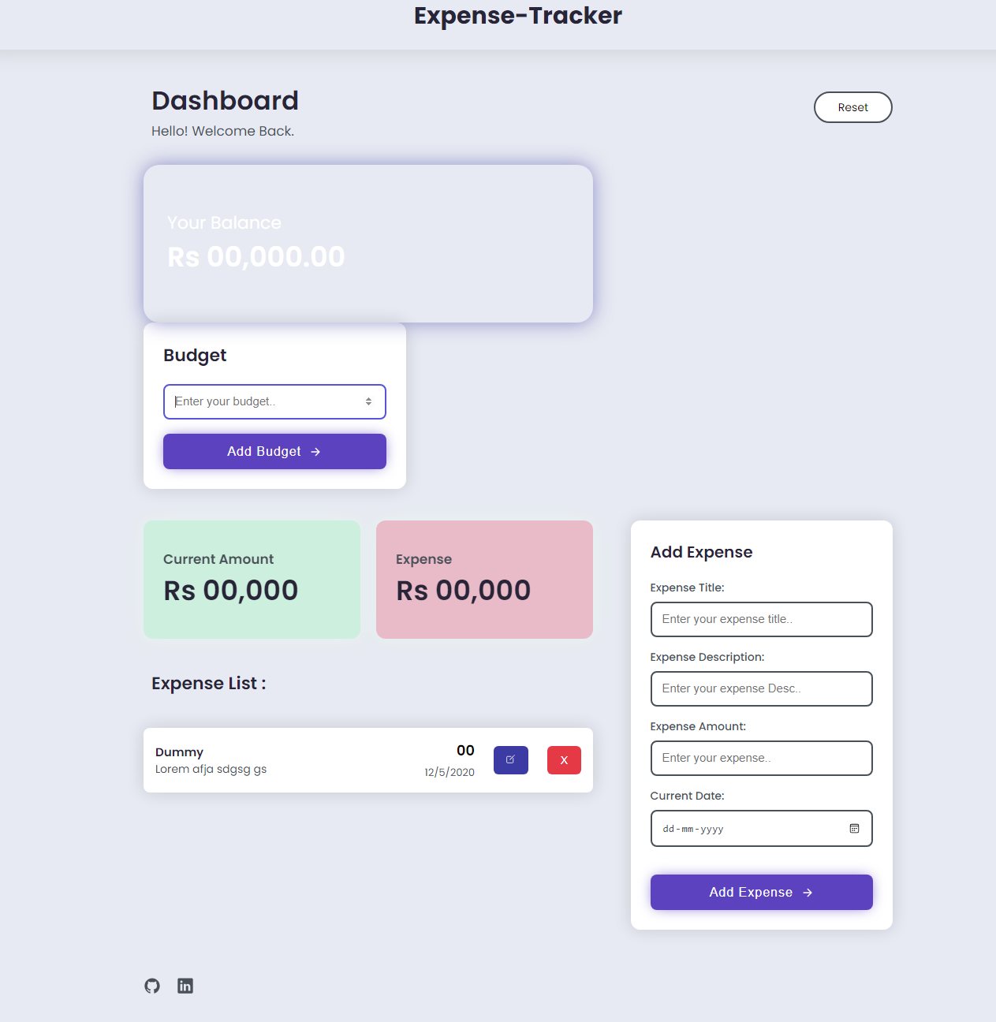

**Fig 5.3 : Dashboard**

**BIBLIOGRAPHY**

1. “Daily Expense 3 - Apps on Google Play.” [Online]. Available: https://play.google.com/store/apps/details?id=mic.app.gas tosdiarios .
2. . “Monefy - Money Manager - Apps on Google Play.” [Online]. Available: <https://play.google.com/store/apps/details?id=com.monefy.app.lite> [Accessed: 21-Oct-2020].
3. “AndroMoney( Expense Track ) - Apps on Google Play.” [Online]. Available: <https://play.google.com/store/apps/details?id=com.kpmoney> android. [Accessed: 21-Oct-2020].
4. Chandini, S. Poojitha, T., Ranjith, D., Akram, V. M., Vani, M. S., & Rajyalakshmi, V. (2019). Online Income and Expense Tracker.